Module 1

Assignment 1.3
Course: CSD402-340A Java for Programmers
Prepared By: Mirach Erkol
Date of Report: 1/18/2025

https://github.com/Mikey5007/CSD340.git

1.3 Assignment: Before Corrections
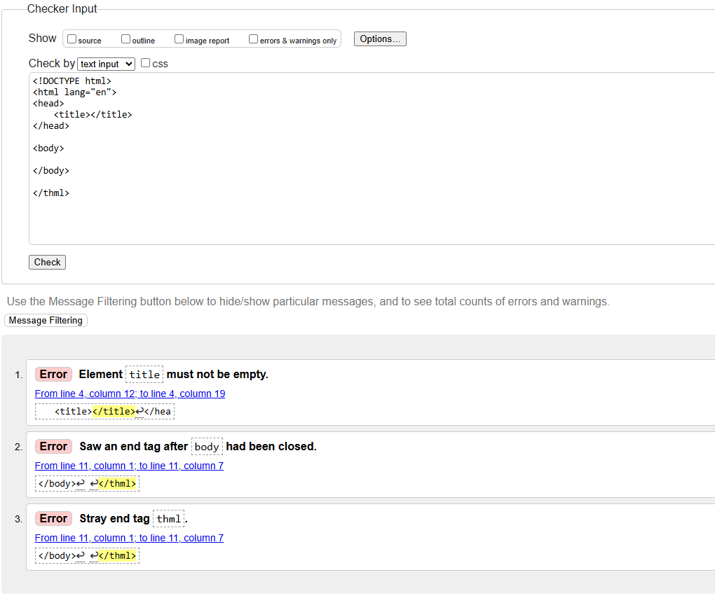

1.3 Assignment: After Corrections
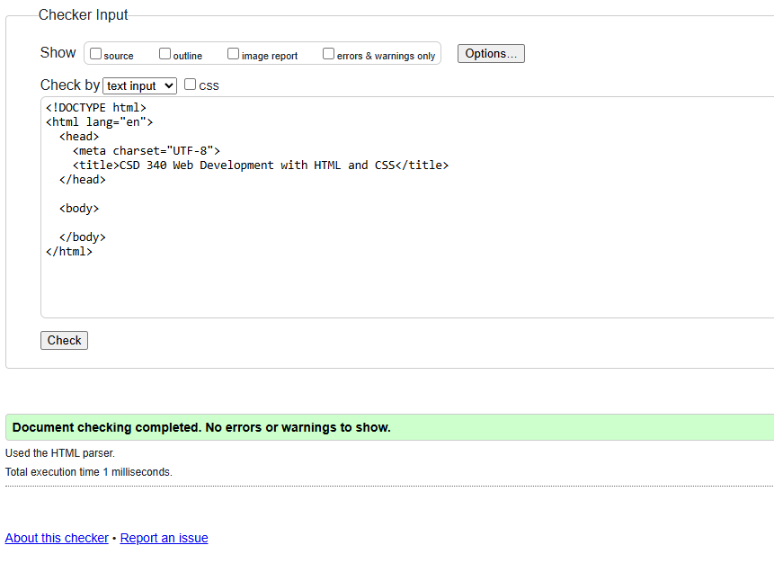

1.3 Assignment: After Corrections and Modifications
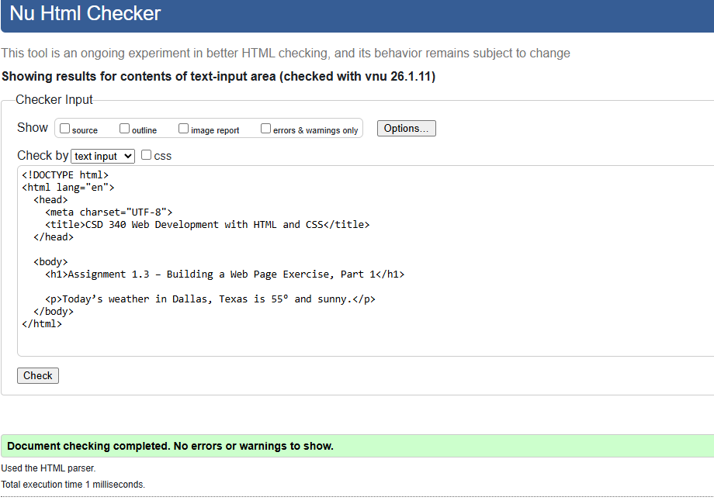

1.3 Assignment: Running in Web Browser
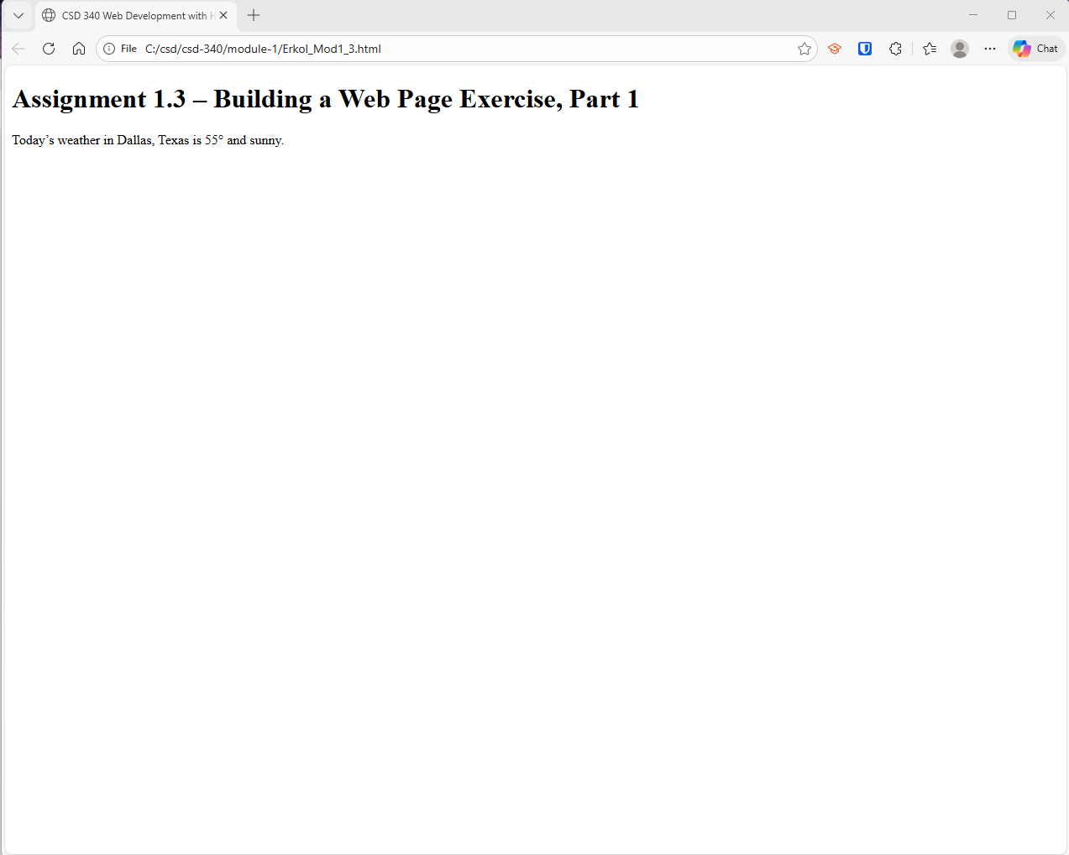

References:

https://github.com/Mikey5007/CSD340.git

